

# Web Development Lab

# PCS – 693

**LAB WORK**

**Submitted To:**  **Submitted By:**

Mr. Sanjeev Kukreti Name: Ashutosh Farswan

Course: B.Tech CSE (DS &AI)

Section: DS

Class Roll No: 20

University Roll No : 2015157

**WEB DEVLOPMENT ASSIGNMENT - 8**

Name : Ashutosh Farswan

Roll: 20

Section: DS

Q1. Write a JavaScript function to get the current date.

<html>

<body>

<script>

var d = new Date();

document.write(d.toISOString());

</script>

</body>

</html>

**OUTPUT:**

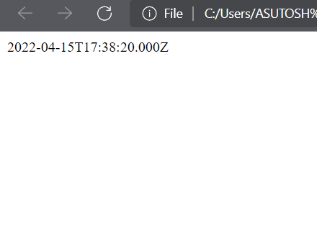

Q2. Write a JavaScript function to get the number of days in a month

Test Data :  
console.log(getDaysInMonth(1, 2012));  
console.log(getDaysInMonth(2, 2012));  
console.log(getDaysInMonth(9, 2012));  
console.log(getDaysInMonth(12, 2012));  
Output :  
31  
29  
30  
31

<html>

<body>

<script>

function getDaysInMonth(month,year){

return (new Date(year, month, 0).getDate());

}

console.log(getDaysInMonth(1, 2012));

console.log(getDaysInMonth(2, 2012));

console.log(getDaysInMonth(9, 2012));

console.log(getDaysInMonth(12, 2012));

</script>

</body>

</html>

**OUTPUT:**

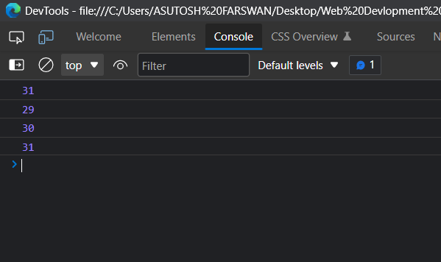

Q3.Write a JavaScript function to get the month name from a particular date

Test Data :  
console.log(month_name(new Date("10/11/2009")));  
console.log(month_name(new Date("11/13/2014")));  
Output :  
"October"  
"November"

<html>

<body>

<script>

function month_name(dt){

mlist = [ "January", "February", "March", "April",

"May", "June", "July", "August", "September",

"October", "November", "December" ];

return mlist[dt.getMonth()];

};

console.log(month_name(new Date("10/11/2009")));

console.log(month_name(new Date("11/13/2014")));

</script>

</body>

</html>

**OUTPUT:**

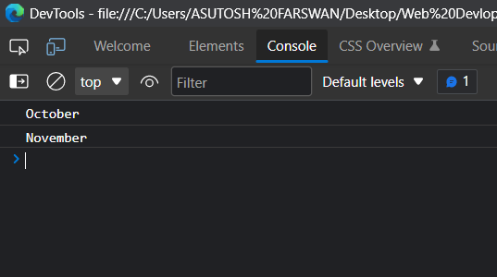

**4.** Write a JavaScript program to display the current day and time in the following format. 

Sample Output :

Today is : Friday.   
Current time is : 4 PM : 50 : 22

<html>

<body>

<script>

var today = new Date();

var day = today.getDay();

var daylist = ["Sunday","Monday","Tuesday","Wednesday ","Thursday","Friday","Saturday"];

console.log("Today is : " + daylist[day] + ".");

var hour = today.getHours();

var minute = today.getMinutes();

var second = today.getSeconds();

var prepand = (hour >= 12)? " PM ":" AM ";

hour = (hour >= 12)? hour - 12: hour;

if (hour===0 && prepand===' PM '){

if (minute===0 && second===0){

hour=12;

prepand=' Noon';

}

else{

hour=12;

prepand=' PM';

}

}

if (hour===0 && prepand===' AM '){

if (minute===0 && second===0){

hour=12;

prepand=' Midnight';

}

else{

hour=12;

prepand=' AM';

}

}

console.log("Current Time : "+hour + prepand + " : " + minute + " : " + second)

</script>

</body>

</html>

**OUTPUT:**

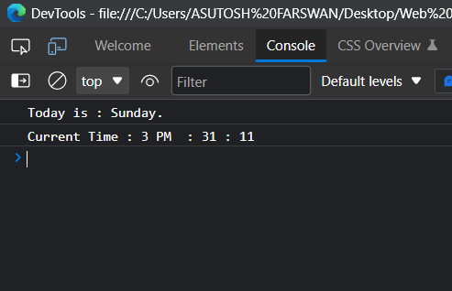

**Q5.** Write a JavaScript program to get the current date. 

*Expected Output*:   
mm-dd-yyyy,

mm/dd/yyyy or dd-mm-yyyy,

dd/mm/yyyy

<html>

<body>

<script>

var today = new Date();

var dd = today.getDate();

var mm = today.getMonth()+1;

var yyyy = today.getFullYear();

if(dd<10) {

dd='0'+dd;

}

if(mm<10) {

mm='0'+mm;

}

today = mm+'-'+dd+'-'+yyyy;

console.log(today);

today = mm+'/'+dd+'/'+yyyy;

console.log(today);

today = dd+'-'+mm+'-'+yyyy;

console.log(today);

today = dd+'/'+mm+'/'+yyyy;

console.log(today);

</script>

</body>

</html>

**OUTPUT:**

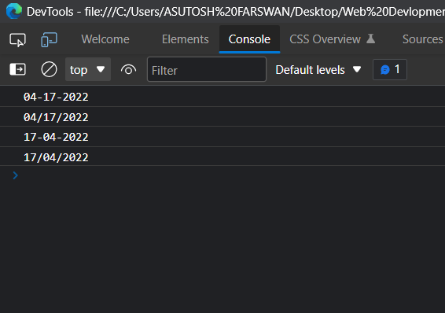

Q6 Write a JavaScript function to get difference between two dates in days.

Test Data :  
console.log(date_diff_indays('04/02/2014', '11/04/2014'));  
console.log(date_diff_indays('12/02/2014', '11/04/2014'));

Output :

216

-28

<html>

<body>

<script>

var date_diff_indays = function(date1, date2) {

dt1 = new Date(date1);

dt2 = new Date(date2);

return Math.floor((Date.UTC(dt2.getFullYear(), dt2.getMonth(), dt2.getDate()) - Date.UTC(dt1.getFullYear(), dt1.getMonth(), dt1.getDate()) ) /(1000 * 60 * 60 * 24));

}

console.log(date_diff_indays('04/02/2014', '11/04/2014'));

console.log(date_diff_indays('12/02/2014', '11/04/2014'));

</script>

</body>

</html>

**OUTPUT:**

